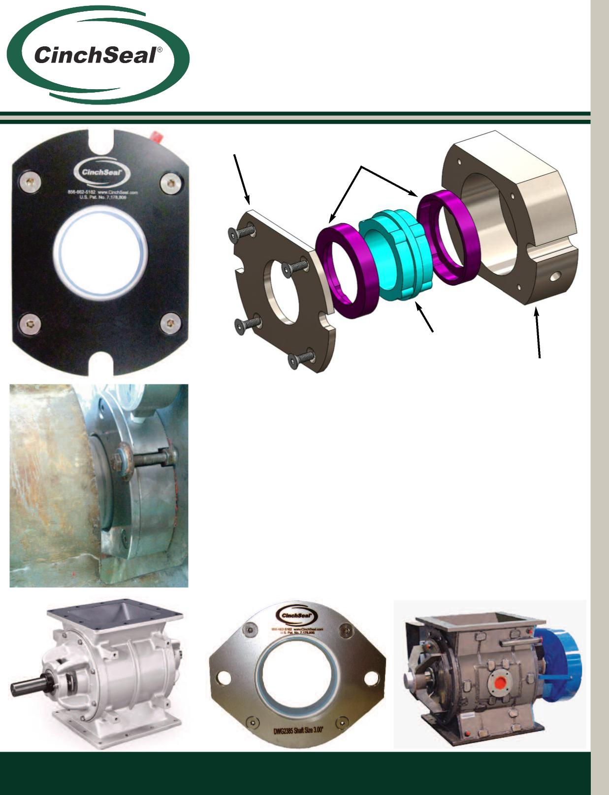

**Rotary Air Lock Seal**

**Cover Plate**

**Solid PTFE Rotor Cups**

**Solid Boot**

**Solid Housing**

* Designed to replace rope packing on rotary air locks
* Zero maintenance due to self-adjusting design
* Custom seal housings available in Aluminum and SS
* Seals can be rebuilt with inexpensive repair kits
* Designed to handle 1/4” total radial shaft runout
* Designed to be air purged at 7 PSI over vessel pressure
* Designed for temperature ranges -50F to 400F

**CinchSeal • 731 Hylton Road • Pennsauken, NJ • 08110 856.662.5162 • 856.662.5264 •** [**www.cinchseal.com**](http://www.cinchseal.com)